**FACT SHEET**

**(State Name) Wetlands and the Release of the National Wetland Condition Assessment (NWCA)** [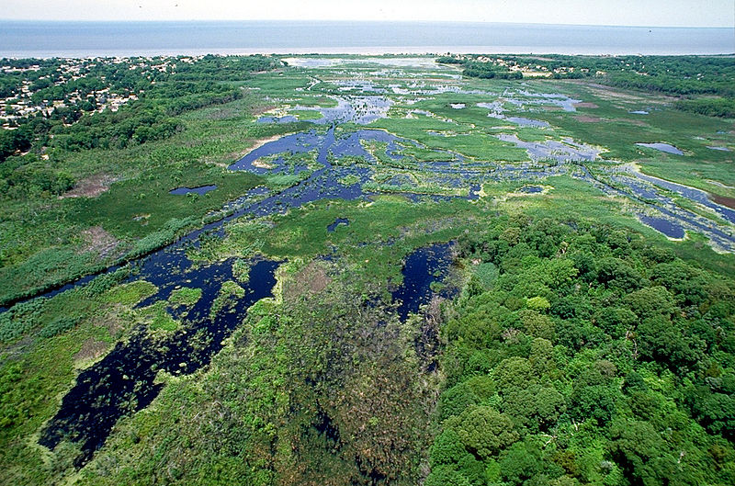](http://upload.wikimedia.org/wikipedia/commons/d/de/Wetlands_Cape_May_New_Jersey.jpg)

*Photo title: Provide name of wetland and location*

*Photo Credit: Anthony Bley, USACOE*

**Did You Know?**

*(Add appropriate bullets here; examples provided below –you may want to focus on ecosystem services; don’t use acronyms or technical language. For example: Sediment retention = limit erosion)*

* **Commercial fishing** in (State) is a $X million a year industry that employs X# state citizens? Sport fishing and hunting are important attractions to the tourists and seasonal residents who make tourism a $X billion a year industry employing another X# citizens. The majority of commercial and sport fish species spend some portion of their life cycle in wetland habitat.
* Tens of thousands of **hunters and trappers** in (State) know that wetlands mean valuable game, whether it is ducks in coastal salt marshes or deer, bear and small furbearers foraging in freshwater wetland habitat.
* Wetlands are the source of over three million acres of productive timberland, vital to the state’s **forest products industry** which provides jobs for X# workers in (State).
* (State)’s wetlands save millions of dollars annually through **erosion control, reduced flood damage and pollution abatement.**  Their water quality and flood control functions protect the public from otherwise harmful effects. (You may want to relate this information to a specific event, e.g. Hurricane Sandy, flooding or other)
* Over X% of all wildlife-related recreation in (State) is wildlife watching. Annually, over X citizens and visitore visit (State) to enjoy its natural beauty and view rare plants and wildlife. (List well-known specied here)call (State)’s wetlands home. (Statistics for your state can be found here: <http://www.census.gov/prod/www/fishing.html>)

**What is the National Wetland Condition Assessment?**

The U.S. Environmental Protection Agency released their assessment of the condition of wetlands across the United States on (Add Date). The National Wetland Condition Assessment (NWCA) is the first-ever national survey on the ecological condition of the Nation's wetlands and is one of the five National Aquatic Resource Surveys initiated in 2006. These studies provide nationally-consistent and scientifically-defensible assessments of our lakes, rivers, wadeable streams, coastal waters, and wetlands, and can be used to track changes over time. The purpose of the survey is to generate statistically-valid and environmentally relevant reports on the condition of the Nation’s wetlands. Of the 1,138 sites nationwide, a total of X wetland sites were selected by the EPA for assessment in (State), including X (wetland type), X (wetland type) and X (wetland type). The study is the product of cooperation and collaboration between EPA, states officials and scientists. EPA provided the funding for the study and states provided the fieldwork and expertise to complete the assessment.

**EPA National Aquatic Resource Surveys (NARS) are conducted every five years to evaluate changes in wetland condition over time**

|  |  |  |  |  |
| --- | --- | --- | --- | --- |
| 2007 | 2008 | 2009 | 2010 | **2011** |
| Lakes | Rivers | Wadeable Streams | Coastal Waters | **WETLANDS** |
|  |  |  |  | **→** |
| 2012 | 2013 | 2014 | 2015 | **2016** |
| Lakes | Rivers | Wadeable Streams | Coastal Waters | **WETLANDS** |

**The NWCA is being used to:**

* Determine the national & regional condition of wetlands (NWCA findings are not state-specific)
* Develop baseline information to evaluate change in condition over time
* Build state and tribal capacity for monitoring and analyses

Results and findings from the NWCA are not being used by EPA or the state to provide state-level information or for regulatory purposes.

**Key findings from the NWCA 2014 Report include:**

*(Insert appropriate bullets here)*

* Add here
* Add here

**What the NWCA tells us about (State Name) Wetlands**

*(Insert appropriate bullets here)*

**[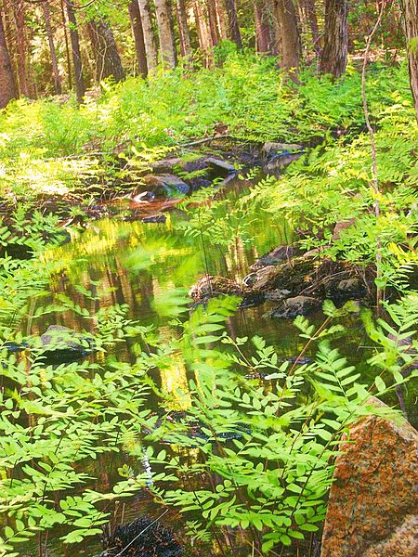](http://upload.wikimedia.org/wikipedia/commons/0/03/WETLANDS.jpg)**

The EPA NWCA Projects’ objective was to assess wetland condition at the national and regional level, but not the state level. While it can’t tell us a lot about state-specific wetland conditions, it can tell us about specific ways to look at and assess wetland condition, how wetland condition looks in our region and emphasizes the value of monitoring and assessment data for our state’s management of natural and water resources*. (If your state is a state where an intensification study was conducted, you can add this additional information):* EPA worked with our state to modify the NWCA design to include state-specific objectives, In (State) sufficient additional wetland sites were sampled to assess conditions at the state level. Findings from this additional state-level statistical assessment of wetland condition suggests that (State)’s wetlands are generally in a (similar/not similar) ecological condition to the findings of the NWCA. To learn more about the NWCA or download the complete report, go to: <http://water.epa.gov/type/wetlands/assessment/survey/index.cfm>

**Protecting (State)’s Wetlands**

*(Add appropriate bullets here; examples provided below –* note: If your state already has strong protections, may want to add that this continues to focus on improving functions).

The NWCA provides an opportunity for New Jersey to highlight the importance of high quality wetlands so that they can provide the functions and services that support our state’s economy. More than X percent of (State)’s land area is wetlands. (May want to tie in with state-important information (example: Hurricane Sandy, drought, etc.) and the impacts that wetlands can have on protecting against these threats/buffering impacts.)

What We Need from You:

* Encourage enforcement of federal and state laws protecting wetlands
* Support funding for monitoring and assessment
* Experience (State)’s wetlands with your family and friends

**For More Information:**

Contact Bob Smith at the State Wetland Program *Add as appropriate - Like us on FB, Twitter, etc.*

Street Address. City/State/Zip

Telephone: (123) 123-1234; Email [Bob.Smith@state.gov](mailto:Bob.Smith@state.gov); Website Address;