**[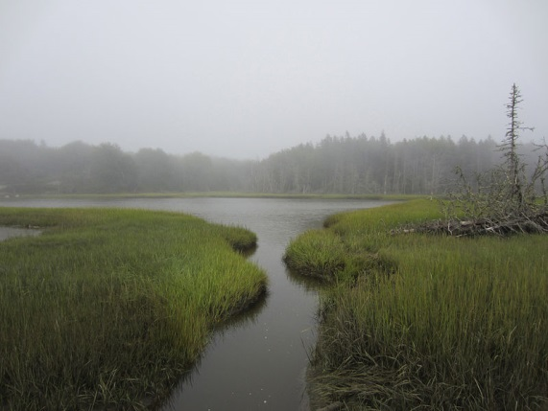](http://upload.wikimedia.org/wikipedia/commons/4/48/Pleasant_River_August_2012_Aviva_Rahmani.jpg)Implications of the National Wetland Condition Assessment (NWCA) Report for the (State/Tribe Name)**

A new EPA Report Assesses the Condition Wetlands Nationwide.

In 2014, the U.S. Environmental Protection Agency released their first assessment of the condition of wetlands across the United State/Tribes, called the *National Wetland Condition Assessment*. (NWCA).

**EPA National Aquatic Resource Surveys (NARS) are conducted every five years to evaluate changes in wetland condition over time**

|  |  |  |  |  |
| --- | --- | --- | --- | --- |
| 2007 | 2008 | 2009 | 2010 | **2011** |
| Lakes | Rivers | Wadeable Streams | Coastal Waters | **WETLANDS** |
|  |  |  |  | **→** |
| 2012 | 2013 | 2014 | 2015 | **2016** |
| Lakes | Rivers | Wadeable Streams | Coastal Waters | **WETLANDS** |

The NWCA is one of the five National Aquatic Resource Surveys initiated in 2006. These studies provide nationally consistent and scientifically defensible assessments of our lakes, rivers, wadable streams, coastal waters, and wetlands, and can be used to track changes over time. The purpose of the survey is to generate statistically valid and environmentally relevant reports on the condition of the Nation’s wetlands.

Of the ____ sites nationwide, a total of __ wetland sites were selected by the EPA for assessment in (State/Tribe), including __ (wetland type)s, ___ (wetland type)s and ___ (wetland type)s.

The NWCA study is the product of cooperation and collaboration between EPA, state officials and scientists. EPA provided the funding for the study and states provided the fieldwork and expertise to complete the assessment. To learn more about the NWCA or download the complete report, go to: <https://www.epa.gov/national-aquatic-resource-surveys/nwca>

**Key findings and conclusions from the NWCA include:**

*(Insert brief summary of NWCA findings relevant to your State/Tribe/Tribe)*

* Overall condition of nation’s wetlands
* The report finds that wetlands in our ecoregion are in (insert condition from report here) condition

**[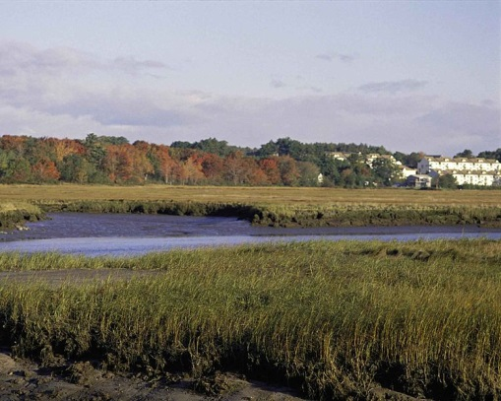](http://upload.wikimedia.org/wikipedia/commons/e/e0/Rachel_Carson_national_wildlife_refuge_maine.jpg)How the** **NWCA relates to our work to protect (State/Tribe)’s wetlands:**

The EPA NWCA Projects’ objective is to assess wetland condition at the national and regional level, but not the state level. (*If your state is a state where an intensification was conducted, you can add this additional information*): To determine the condition of wetlands in our state, the EPA has funded a multi-year intensification study, which will be completed in 2016. Findings from this additional state -level statistical assessment of wetland condition suggests that (State/Tribe)’s wetlands are generally in a (similar/not similar) ecological condition to the findings of the NWCA. Our State/Tribe will also be conducting additional analysis of this data.

**The NWCA is being used to:**

* Determine the national & regional condition of wetlands (NWCA findings are not state-specific)
* Develop baseline information to evaluate change in wetland condition over time
* Build state and tribal capacity for monitoring and analyses

*Note: Results and findings from the NWCA are not being used by EPA or the state to provide State-level information or for regulatory purposes.*

**What are Wetlands?**

Wetlands are part of the foundation of our nation's water resources and are vital to the health of waterways and communities that are downstream. Wetlands feed downstream waters, trap floodwaters, recharge groundwater supplies, remove pollution, and provide fish and wildlife habitat. Wetlands include swamps, marshes and bogs. Wetlands vary widely because of differences in soils, topography, climate, hydrology, water chemistry, vegetation, and other factors.

**Wetlands economic drivers in (State/Tribe) because of their key role in the State/Tribe’s water quality, fishing, hunting, agriculture and recreation industries.**

**Did you know that (State/Tribe’s name) wetlands provide critical services that support our economy? Wetlands provide:**

*(Insert appropriate bullets here)*

* Contributions to clean water, flood control, groundwater recharge and other critical services,
* Nurseries for the vast majority of the State/Tribe’s commercial and sport fish,
* Critical habitat for the State/Tribe’s game and hunting industry,
* Natural resources relied on by the timber industry, and
* Habitat for hundreds of endangered species?

[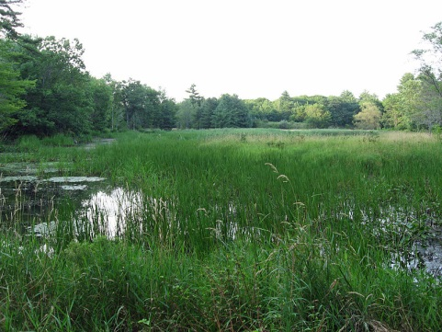](http://upload.wikimedia.org/wikipedia/commons/a/a8/Wetland_on_Marsh_Island.JPG)These services can save taxpayers hundreds of millions of dollars from water treatment facilities not having to clean more polluted water, from property damage from floods and storm surges and other expenses.

**What are the biggest threats to (State/Tribe’s name) Wetlands?**

*(Insert appropriate bullets here)*

* Fragmentation, development and poor land management practices
* Recreational and agricultural disturbances
* Storm surge and sea-level rise
* Stormwater pollution
* Invasive species

***Heading Option A:* What can be done to Better Protect (State/Tribe’s) Wetlands?**

***Heading Option B:* While (State/Tribe) does a great job at protection its wetlands, what do we need in order to improve the condition of those wetlands?**

*(Insert appropriate bullets here)*

* More public awareness of the intrinsic and economic value of (State/Tribal) wetlands
* Increased monitoring & assessment to target resources more effectively, which can result in reduced costs and reduce property damage
* Consideration of wetlands in other areas of decision making
* Living shorelines and coastal resiliency

**To learn more about what our state/tribe is doing to protect wetlands,** we encourage you to look at our state wetland program plan (insert web address to appropriate plan here). (State may want to list the core elements that they emphasize, e.g. regulation and monitoring and assessment).

**Actions (citizens/tribal residents and members) can to take to protect and restore our State/Tribe’s wetlands:**

*(Insert appropriate bullets here)*

* Consider wetland issues when you are working with others on flooding, pollution, storm surge and climate change issues. *Wetlands can play a critical role in reducing these impacts!*
* For State ---Better compliance with state rules and regulations that protect wetlands (Dredge and Fill Permitting, NPDES, etc.) **OR For Tribe ---** Support conservatory and stewardship practices of the tribe’s wetlands (Dredge and Fill Permitting, NPDES, CAMA permitting, etc.)
* Increase State/Tribe support for wetland monitoring and assessment

**Please Direct Questions about the NWCA Report/State/Tribe Wetlands to:**

**(State/Tribe) Wetland Program Contact**

Joe Wetlands, State/Tribe Coordinator; Address: State/Tribe Drive, City, State/Tribe, Zip; Email/Phone: [jwetlands@State/Tribe.gov](mailto:jwetlands@state.gov), (111) WET-LANDS

**The Association of State Wetland Managers**

Telephone: (207) 892-3399

Email: brenda@aswm.org

**FREQUENTLY ASKED QUESTIONS**

*The NWCA is likely to illicit some questions from interested parties. Think ahead about what you think will be asked, based on past responses from stakeholders. (Insert relevant Q&As here. The following have been provided as examples.)*

***Q. How will the NWCA Data be Used?***

A. The NWCA data can be used in many ways. These will differ between users, depending on whether they are making decisions at the federal, state/tribal or local level. Examples of potential applications include:

* Results may inform future State/Tribe efforts to protect wetlands under the Clean Water Act (CWA);
* Results may be applied to coastal resiliency efforts in some parts of the country;
* Findings may help State/Tribe permit writers to better understand the condition of certain types of wetlands.

***Q. The report indicates that the region’s wetlands are in great shape. Why do we have such strong protections if they are doing just fine?***

A. While the region’s wetlands may be in generally good condition, that does not mean that all wetlands in the State/Tribe are healthy or protected from threats. There are many critical wetlands in the State/Tribe that are being destroyed or damaged. Specifically, we need to work hard at protecting our coastal wetlands, which serve as critical habitat for the State/Tribe’s seafood industry and a critical part of our State/Tribe’s defense against storm surge and sea level rise. They also play an important role in filtering pollutants from urbanized/urbanizing areas.

***Q. Do dredge and fill permits still need to be filed for work in wetland areas?***

A. Yes. All requirements for the protection of (State/Tribe’s) wetland remain the same as before the report was issued. For more information about permitting, go to: <http://www.specificwebsite.gov>

***Q. Which of (State/Tribe’s) wetlands are most threatened?***

A. All (State/Tribe’s) wetlands have an important role to play in their specific geographic area. The group of wetlands most threatened in our State/Tribe are (insert here; e.g. coastal marshes, prairie potholes). Our State/Tribe’s laws/regulations (add primary protections here, e.g. Coastal Zone Laws and Dredge and Fill permit process) work to protect these, yet losses are still occurring. For a map of (State/Tribe’s) wetlands, go to: <http://www.specificwebsite.gov>

***Q. Why is monitoring and assessment of wetlands important?***

A. Monitoring and assessment allows the State/Tribe to better understand the health and condition of our wetlands and to allocate limited resources to the greatest benefit. Understanding trends and concerns are a critical part of protecting wetland resources. Knowing the health and condition of wetlands allows knowledgeable management decisions to be made about wetland services and benefits, which can result in significant savings to taxpayers.